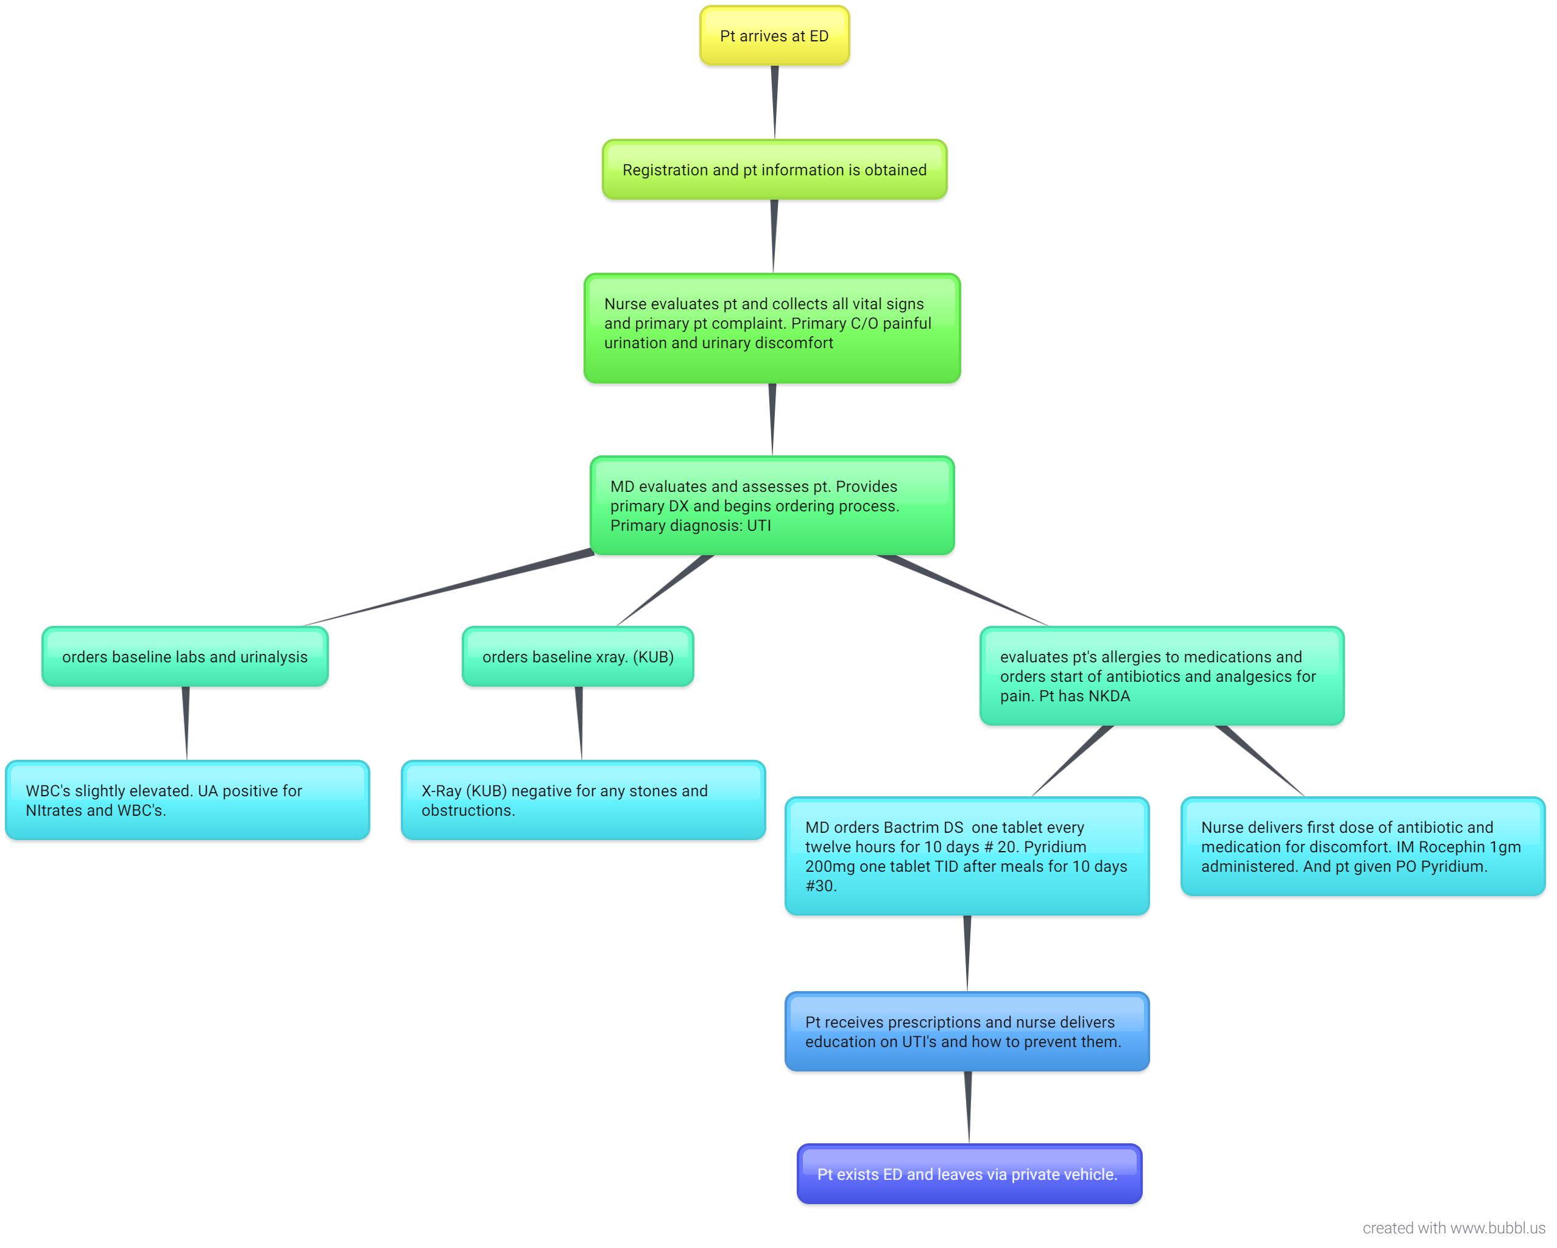

References:

Hobbs, K. (2019). Bubbl.us - brainstorm and mind map online. Retrieved 28 September 2019, from https://bubbl.us/
McGonigle, D., & Mastrian, K. (2018). Nursing informatics and the foundation of knowledge (4th ed., pp. 216-217). Burlington: Jones and Bartlett.

